**Materialized Views- Basic**

To create materialized views necessary system privileges should be granted to user (in my case user – sa_finance). All granted privileges were added in attached file init_users.sql.

Task 01. Create Materialized Views - ON DEMAND

To create materialized view MV_Funding_quarterly, which should be refreshed ON DEMAND SQL script MView_demand(WB_Funding_quarterly).sql (in attached file) for quarterly report was used. Result of script running is presented below.

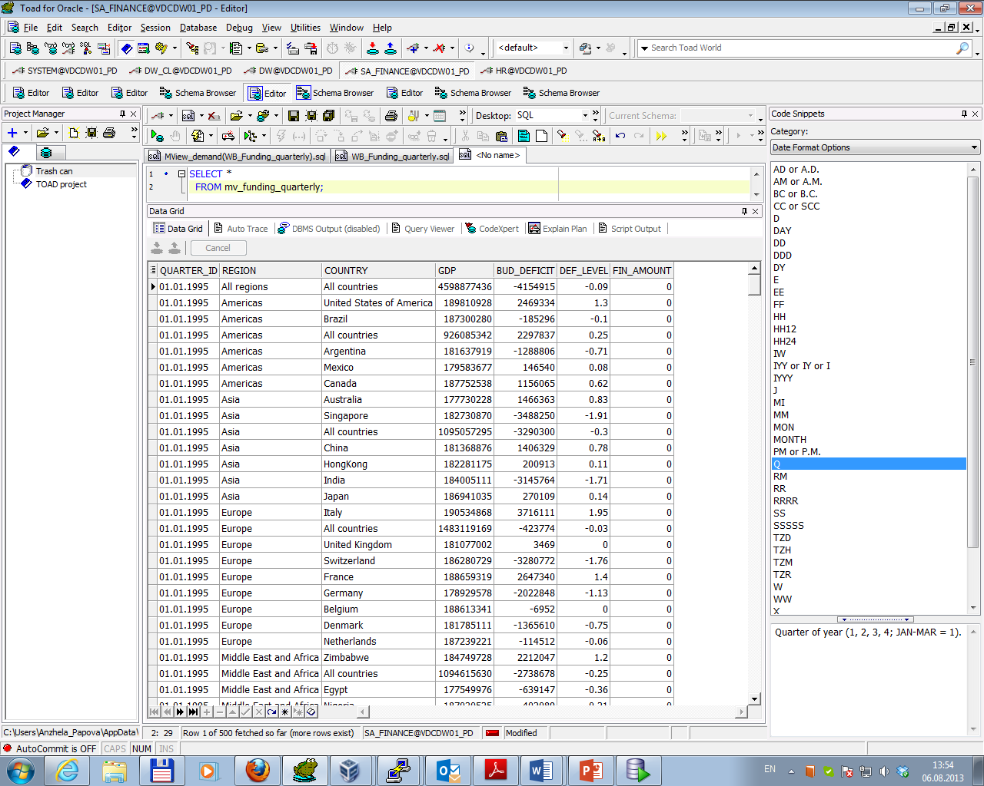

To check query rewriting with different session parameters (query_rewrite_enabled = true / false) command Explain Plan was run. Results are presented below.

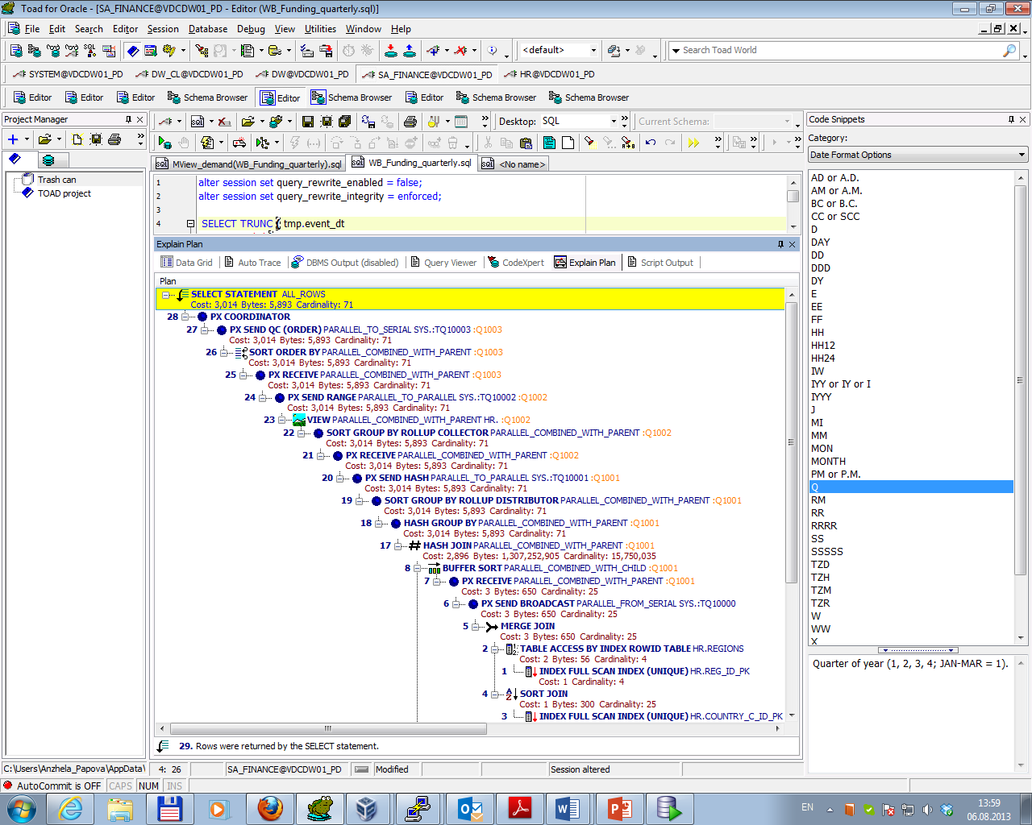

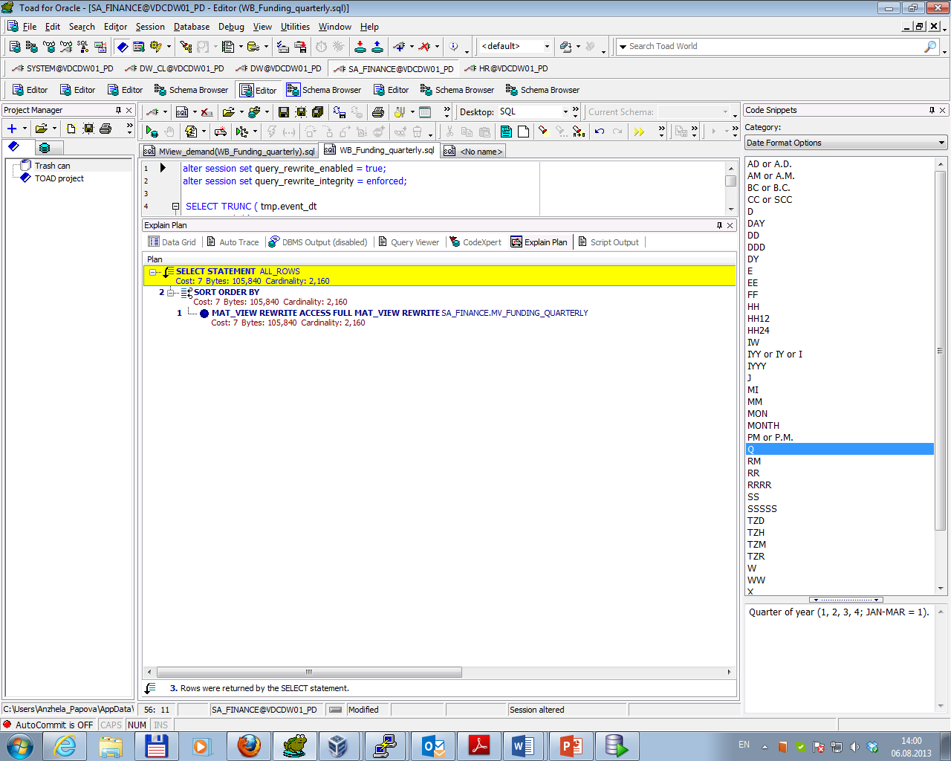

As materialized view MV_Funding_quarterly was created with option Refresh on demand it should be updated by running procedure:

exec dbms_mview.refresh ('mv_funding_quarterly');

Result of successful compliance is presented below.

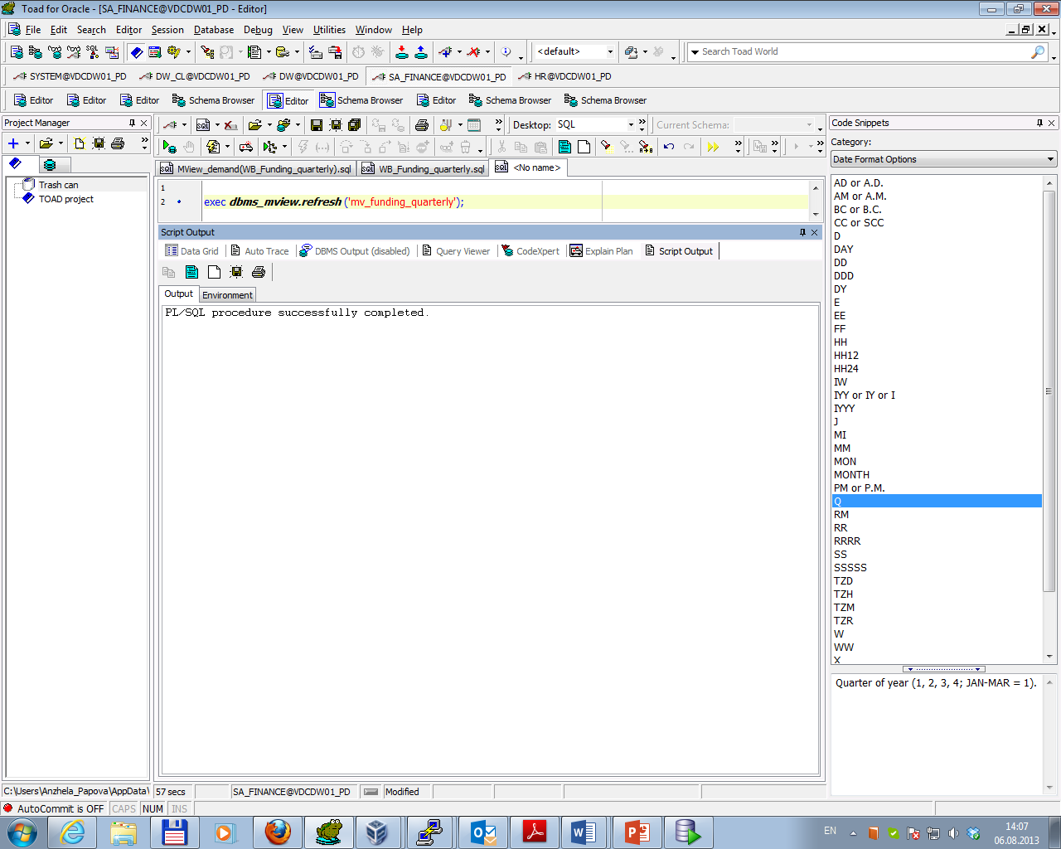

Task 02. Create Materialized Views - ON COMMIT

To create materialized view MV_Funding_monthly, which should be refreshed FAST ON COMMIT SQL script MView_commit(WB_Funding_monthly).sql (in attached file) for monthly report was used.

Additionally materialized view logs for all tables in the materialized view were created (with rowed) and corresponding column COUNT(ff.amount) was added to column SUM(ff.amount).

Result of script running is presented below.

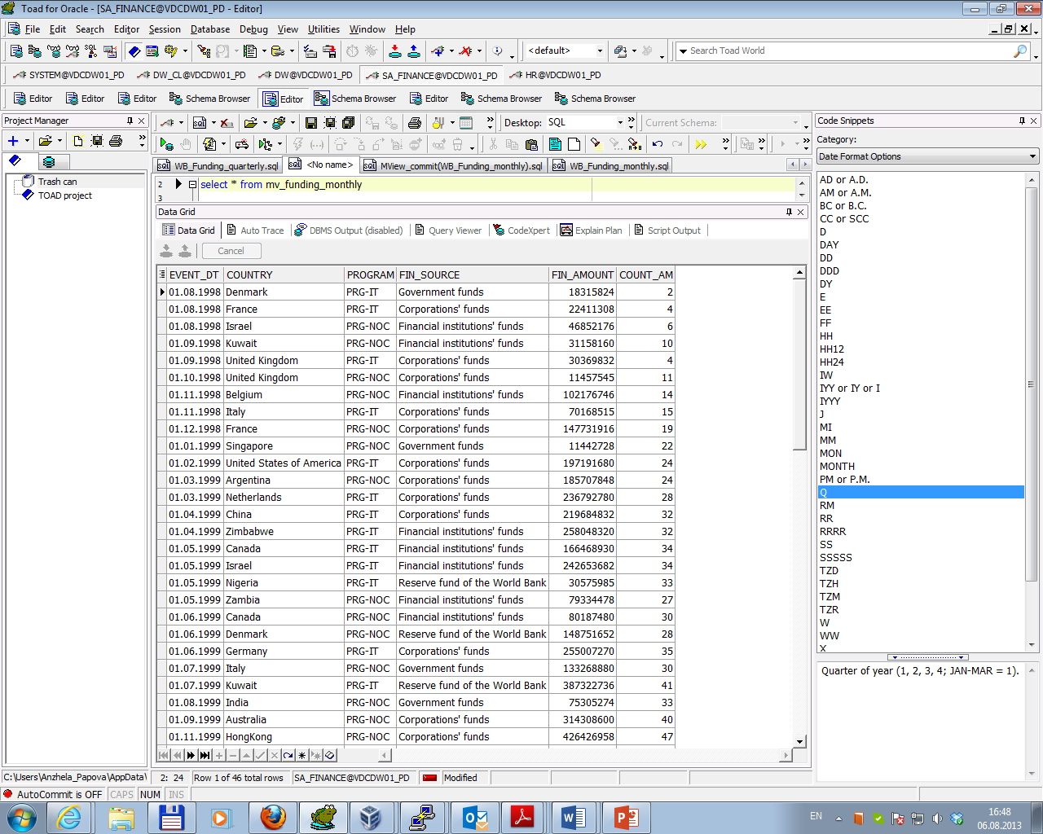

To check query rewriting with different session parameters (query_rewrite_enabled = true / false) command Explain Plan was run. Results are presented below.

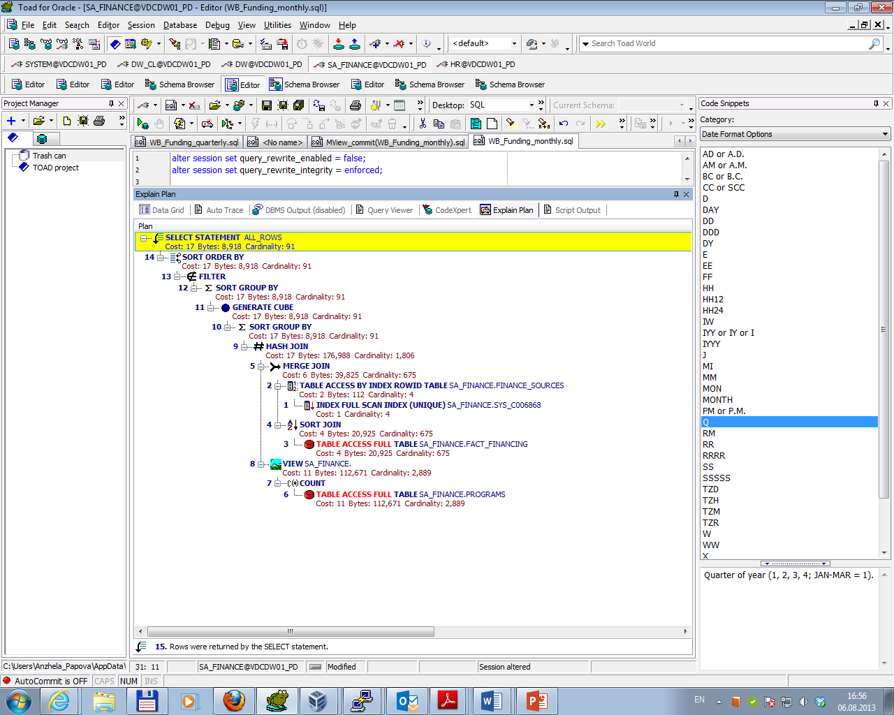

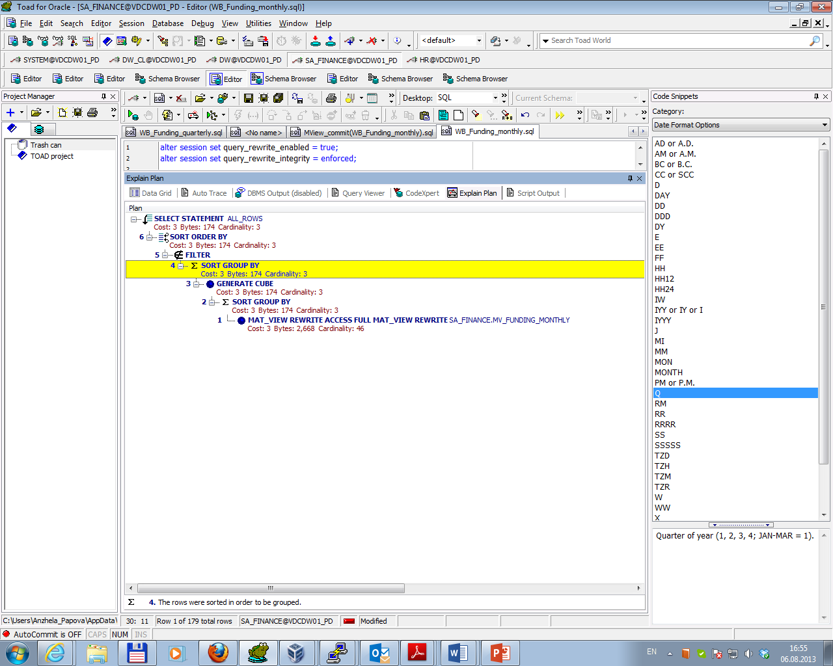

As materialized view MV_Funding_monthly was created with option Refresh on commit it should be updated automatically when a transaction that does DML to one of the materialized view's detail tables commits. To check this SA_FINANCE.FINANCE_SOURCES. FIN_SOURCE_NAME was changed from ‘Government funds’ to ‘Government funds new’. Then change was committed and command select * from MV_Funding_monthly was run. Result is presented below (we could compare this result with the first screenshot at the beginning of Task 02. Create Materialized Views - ON COMMIT).

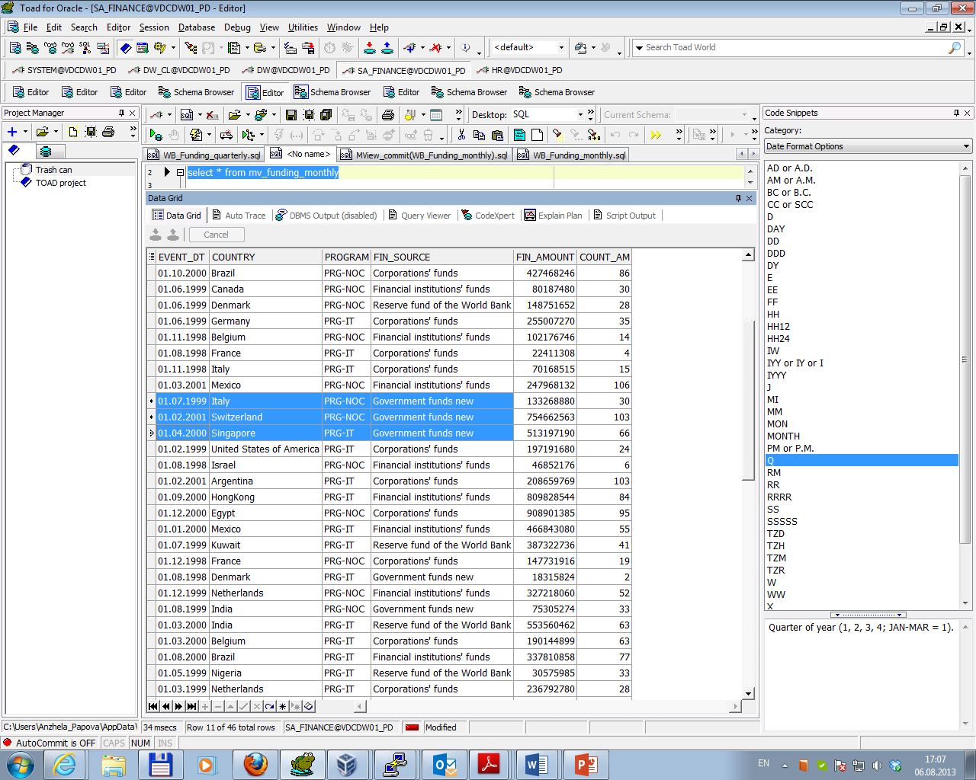

**Materialized Views- Model Clause**

Task 03. Create Materialized Views - Refreshing at definitive Time moment

To create materialized view MV_model_quarterly, which should be refreshed at definite schedule script MView_model(WB_Funding_quarterly).sql (in attached file) for report with Model clause was used.

In the script was set update schedule - every 5 minutes.

Result of script running is presented below.

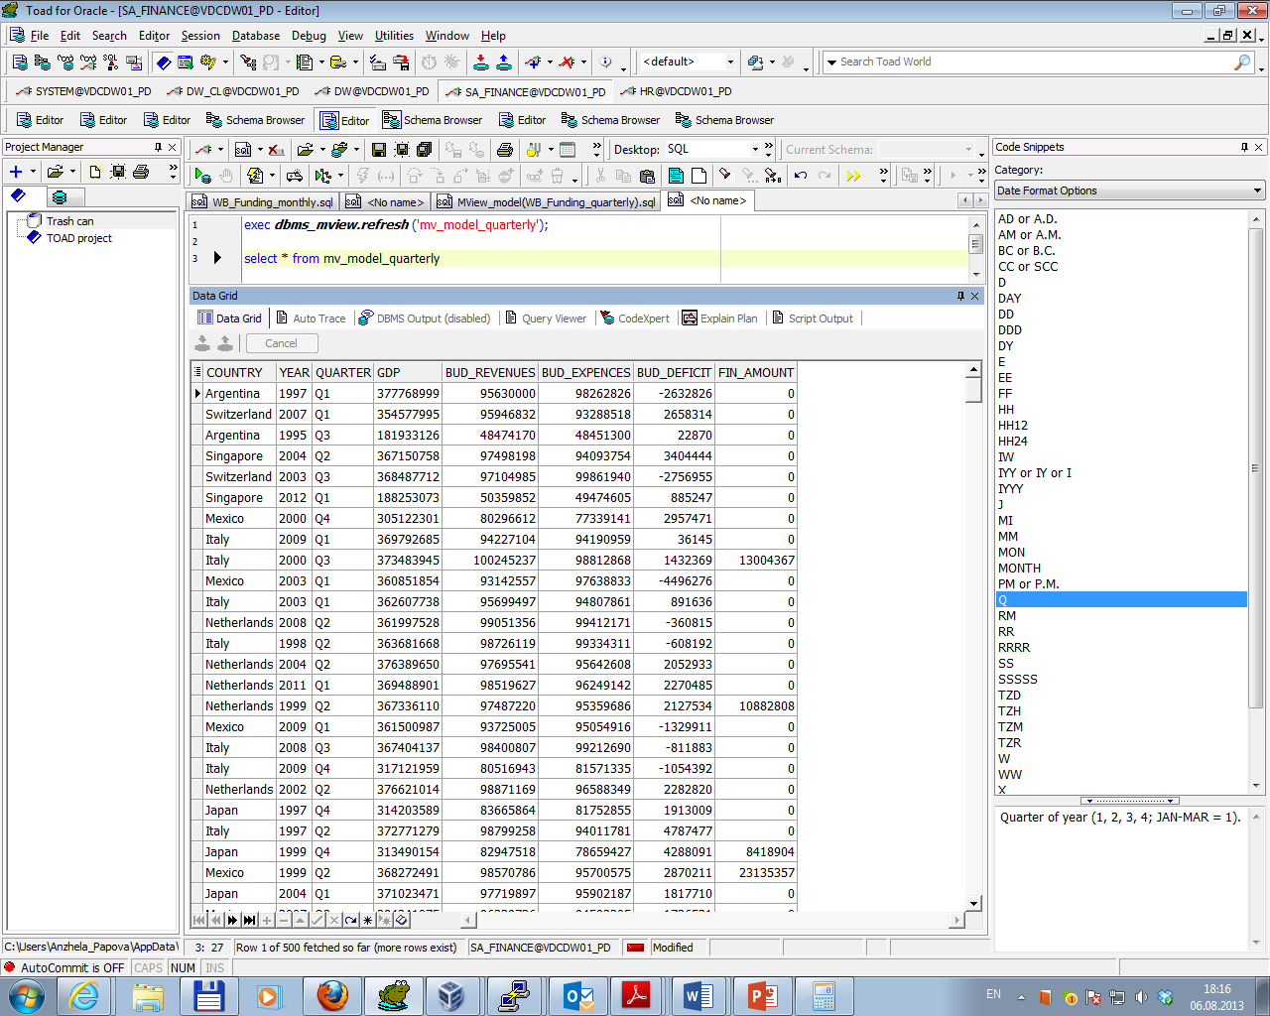

To check query rewriting with different session parameters (query_rewrite_enabled = true / false) command Explain Plan was run. Results are presented below.

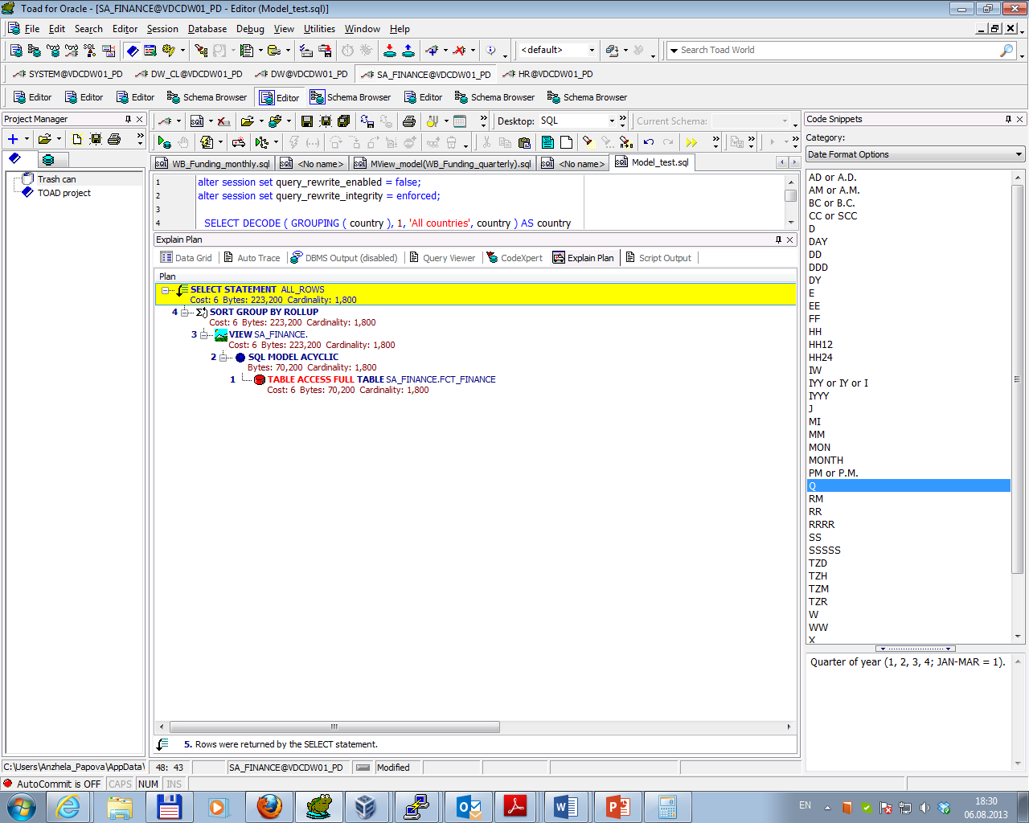

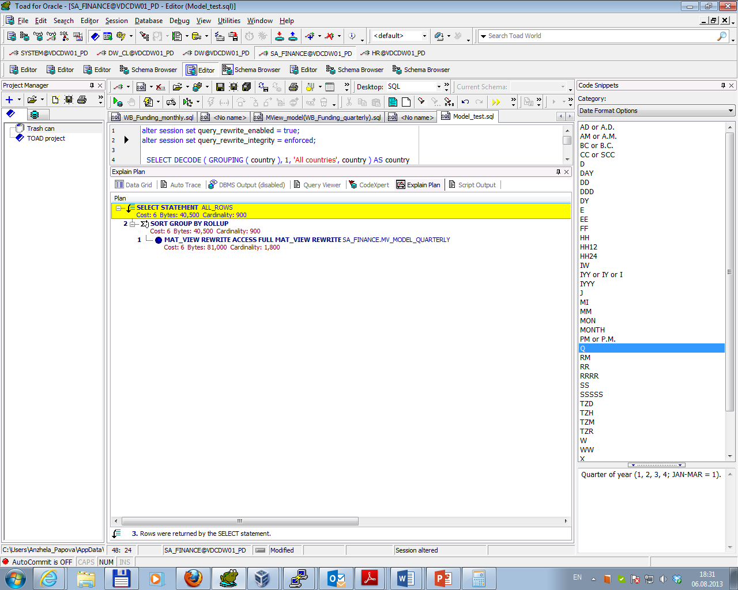

As materialized view MV_model_quarterly was created with option Refresh next SYSDATE+1/288 it should be updated automatically every 5 minutes. To check this SA_FINANCE.FCT_FINANCE.COUNTRY for year = 2008 and quarter = Q3 was changed from ‘Argentina’ to ‘Argentina - good’. Then change was committed and command select * from MV_model_quarterly was run. Result is presented below (we couldn’t see changes yet).

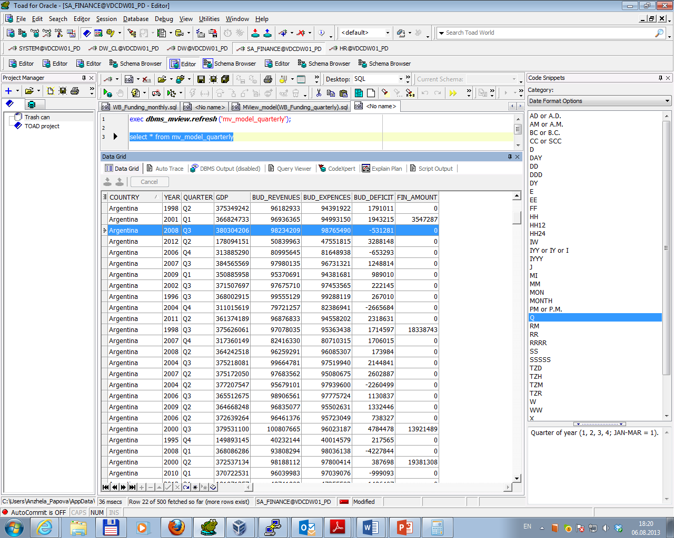

After 5 minutes command select * from MV_model_quarterly was run again. Result is presented below (the data is updated).

